**To Do: Go to This LINK 🡪** [**http://www.schoolsobservatory.org.uk/astro/stars/lifecycle**](http://www.schoolsobservatory.org.uk/astro/stars/lifecycle)

## Life Cycle of a Star

Stars are [formed](http://www.schoolsobservatory.org.uk/astro/stars/birth) in clouds of gas and dust, known as ________________. [_____________ _______________________](http://www.schoolsobservatory.org.uk/astro/stars/fusion) at the center (or core) of stars provides enough energy to make them shine brightly for many years. The exact lifetime of a [star](http://www.schoolsobservatory.org.uk/astro/stars/stars) depends very much on its ______________. Very large, massive stars burn their fuel much faster than smaller stars and may only last a few hundred thousand years. Smaller stars, however, will last for several billion years, because they burn their fuel much more slowly.

Eventually, however, the ________________ fuel that powers the nuclear reactions within stars will begin to run out, and they will enter the final phases of their lifetime. Over time, they will expand, cool and change color to become [__________________________](http://www.schoolsobservatory.org.uk/astro/stars/redgiant). The path they follow beyond that depends on the [mass](http://www.schoolsobservatory.org.uk/astro/esm/mass) of the star. Small stars, like our _____, will undergo a relatively peaceful and beautiful death that sees them pass through a [planetary nebula](http://www.schoolsobservatory.org.uk/astro/stars/planetary) phase to become a _______________________________ **.**

**To do: go to this link** <http://astro.unl.edu/mobile/HRdiagram/HRdiagramStable.html>

HR Diagram

An HR diagram plots the temperature of stars against their luminosity (brightness) and color. The HR diagram also tells us the approximate age of stars in our galaxy.  A copy of an HR diagram can be found on page 15 of your ESRT . You should have this chart in front of you as you watch the podcast below.

Watch the podcast at the following link <https://www.youtube.com/watch?v=LysEUnADpmA&feature=plcp>

When you are finished watching the pod cast answer the following questions using page 15 of your Earth Science Reference table.

1. What color is Polaris? _________________________________________________________   
2. What temperature is Rigel? _____________________________________________________

3. How bright (luminous) is Sirius? _________________________________________________

4. Is Procyon B an old star or a young star? __________________________________________

5. As luminosity increases on the Main Sequence, the temperature of the stars _____________

6. Which stage of life is the Sun currently in? _________________________________________

7. What is the largest star on the chart? ______________________________________________

8. As star color changes from red to white to blue, star temperature does what_____________.

9. What color are the small stars on the Main Sequence? _______________________________

10. What is the name of the brightest white dwarf? ____________________________________

**Regents questions**

1. Which process produces the largest amount of energy given off by stars?

 (1) nuclear fusion of heavier elements into lighter elements

 (2) nuclear fusion of lighter elements into heavier elements

 (3) radioactive decay of lighter elements into heavier elements

 (4) radioactive decay of heavier elements into lighter elements

1. Which characteristics best describe the star Betelgeuse?

(1) reddish orange with high luminosity and low surface temperature

(2) reddish orange with low luminosity and high surface temperature

(3) blue white with low luminosity and low surface temperature

(4) blue white with high luminosity and high surface temperature

1. Which star is cooler and less luminous than the Sun?

 (1) 40 Eridani B(2) Pollux(3) Rigel (4) Proxima Centauri

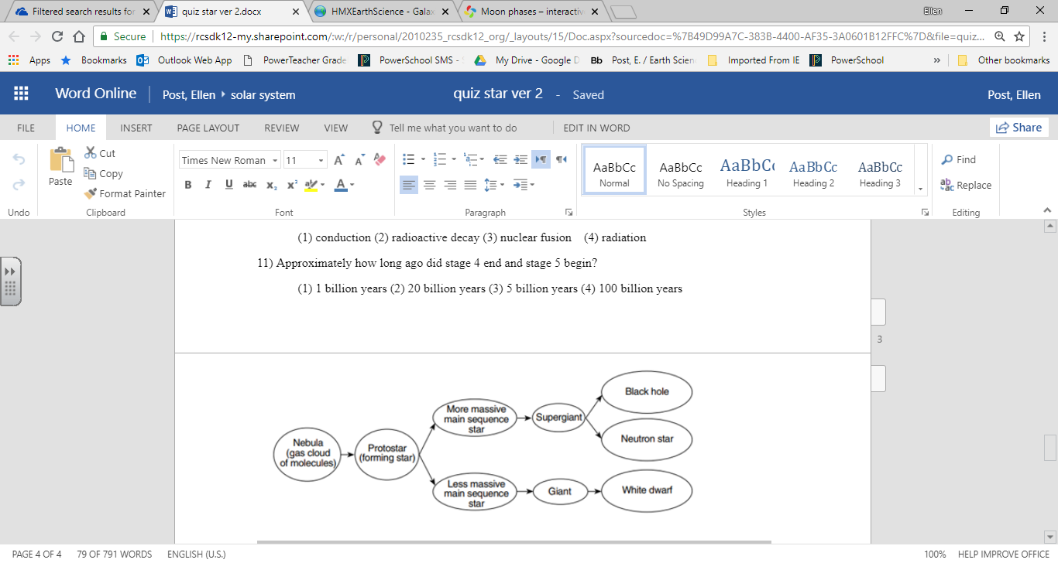

4) Based on this flowchart, identify the characteristic of a main sequence star that determines whether the star becomes a giant or a supergiant.

5 ) State the name of one star labeled on the Characteristics of Stars graph in the Earth Science Reference Tables that may become either a black hole or neutron star.

6 ) Identify the nuclear process that occurs when lighter elements in a star combine to form heavier elements, producing the star’s radiant energy.

**Our Moon**

Moon (lunar) Phases: Visit the websites below and fill in the chart below

* <https://www.youtube.com/watch?v=11yIlRU0MRA>
* <https://www.edumedia-sciences.com/en/media/606-moon-phases>
* <http://highered.mcgraw-hill.com/olcweb/cgi/pluginpop.cgi?it=swf::800::600::/sites/dl/free/0072482621/78778/Lunar_Nav.swf::Lunar%20Phases%20Interactive>

|  |  |
| --- | --- |
| **Moon Phase** | **Sketch of Moon as Seen from Earth** |
| **New Moon** |  |
|  |  |
|  |  |
|  |  |
|  |  |
|  |  |
|  |  |
|  |  |

Lunar Eclipses: Visit the websites below and fill in the chart below

* <http://highered.mcgraw-hill.com/olcweb/cgi/pluginpop.cgi?it=swf::800::600::/sites/dl/free/0072482621/78778/Eclipses_Nav.swf::Eclipse%20Interactive>
* <https://science.howstuffworks.com/solar-eclipse.htm>
* <https://science.howstuffworks.com/lunar-eclipse.htm>

1. Lunar Eclipses:

|  |
| --- |
| Draw a picture of the Sun-Moon-Earth system showing a Lunar Eclipse: |
| Explain in words what happens when a Lunar Eclipse occurs: |

2. Solar Eclipses

|  |
| --- |
| Draw a picture of the Sun-Moon-Earth system showing a Solar Eclipse: |
| Explain in words what happens when a Solar Eclipse occurs: |

Regents questions

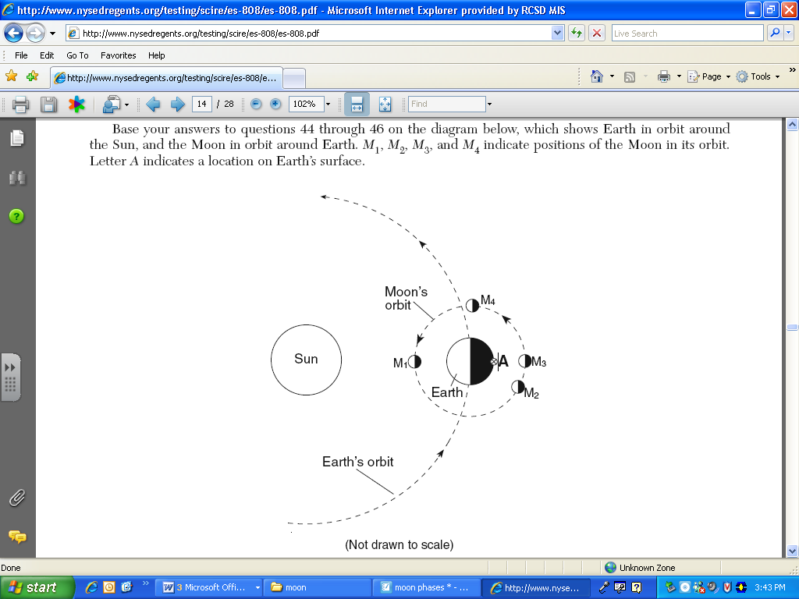Base your answers to questions 1 and 2 on the diagram below which shows Earth in orbit around the Sun and the Moon in orbit around Earth . M1,M2,M3 and M4 indicate positions of the moon in its orbit. Letter A indicates a location on Earth’s surface

1. An observer at location A on Earth views the Moon when it is a position M3. Which phase of the Moon will the observer see?

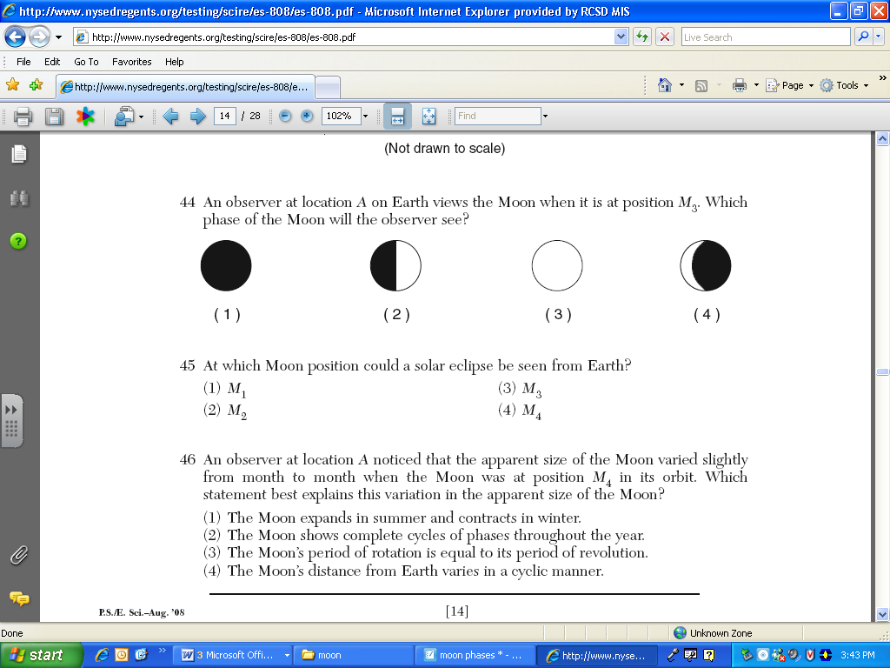

1. At which Moon position could a solar eclipse be seen from Earth?
2. M1  (2) M2 (3) M3 (4) M4

Base your answers to questions 3-5 on the diagram below. The diagram shows the Moon as it revolves around the Earth. The numbered locations represent different positions of the Moon in its orbit

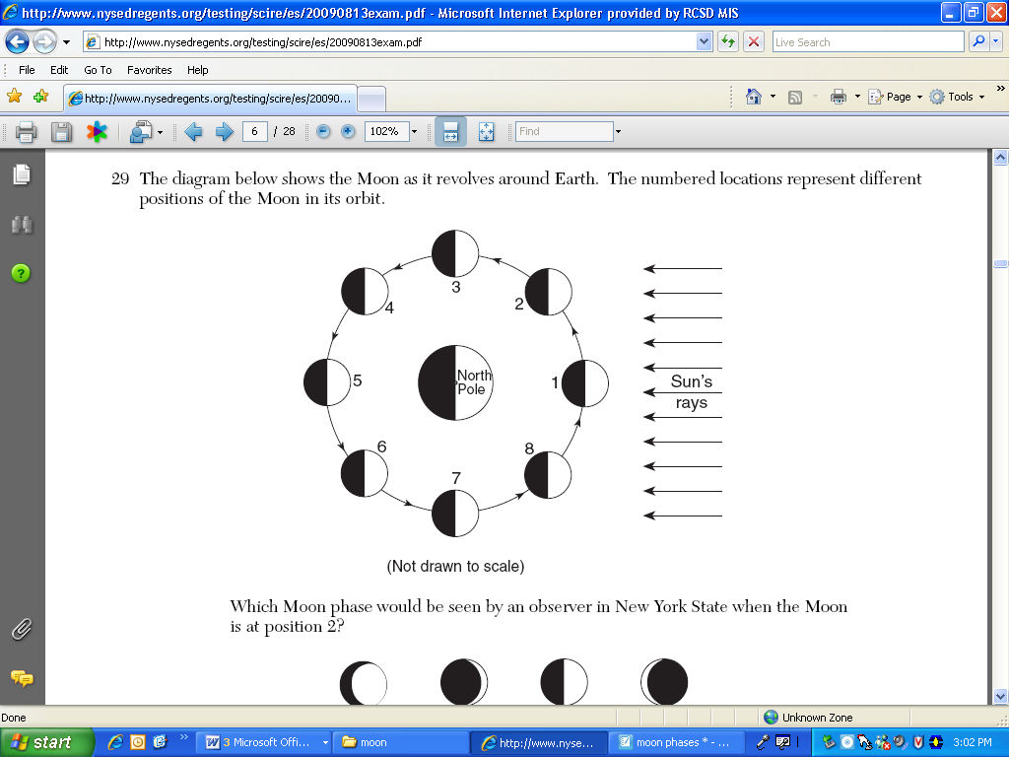

The diagram below shows the Moon’s orbit around Earth. The data table below shows the dates and the phases of moon. Use these diagrams to answer question 6-8

3) With the moon at position 2, what lunar phase is observed from earth? _____________________

4) What lunar phase is observed from earth if the moon is at position 5? ______________________

5) How long does it take for the moon to go through all its phases? _______________________

Ocean Tides:

* <http://astro.unl.edu/classaction/animations/lunarcycles/tidesim.html>
  + (make sure to check all 3 boxes)
* <http://science.howstuffworks.com/environmental/earth/geophysics/tide-cause.htm>

|  |
| --- |
| Explain in words what causes Tides: |
| Draw a picture to show how Tides work: |

Regents question

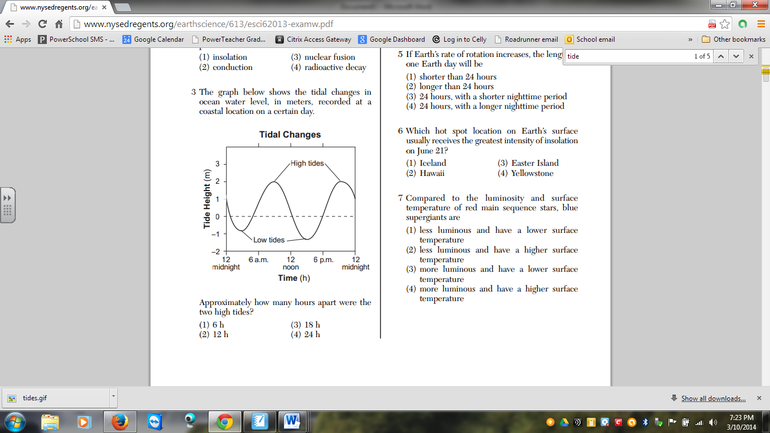The graph below shows the tidal changes in ocean water level, in meters, recorded at a coastal location on a certain day.

1. Approximately how many hours apart were the two high tides?

(1) 6 h (2) 12 h (3) 18 h (4) 24 h